**Vehicle Management System Using Salesforce**

**Project Description:**

Vehicle Management is an application where a customer's Details are stored in order to choose cars, bikes, and commercial vehicles for travel within the city. The data is stored here and further used to remind them if any offers are provided during the seasons and any updates regarding vehicles are sent to them in the form of messages and mail.

* Create a Developer Accountwith these credentials.

URL - <https://virtualemployee-c-dev-ed.develop.lightning.force.com/>

Username - vehiclemanagementsystem@additionalproject.com

Password - anamika@123

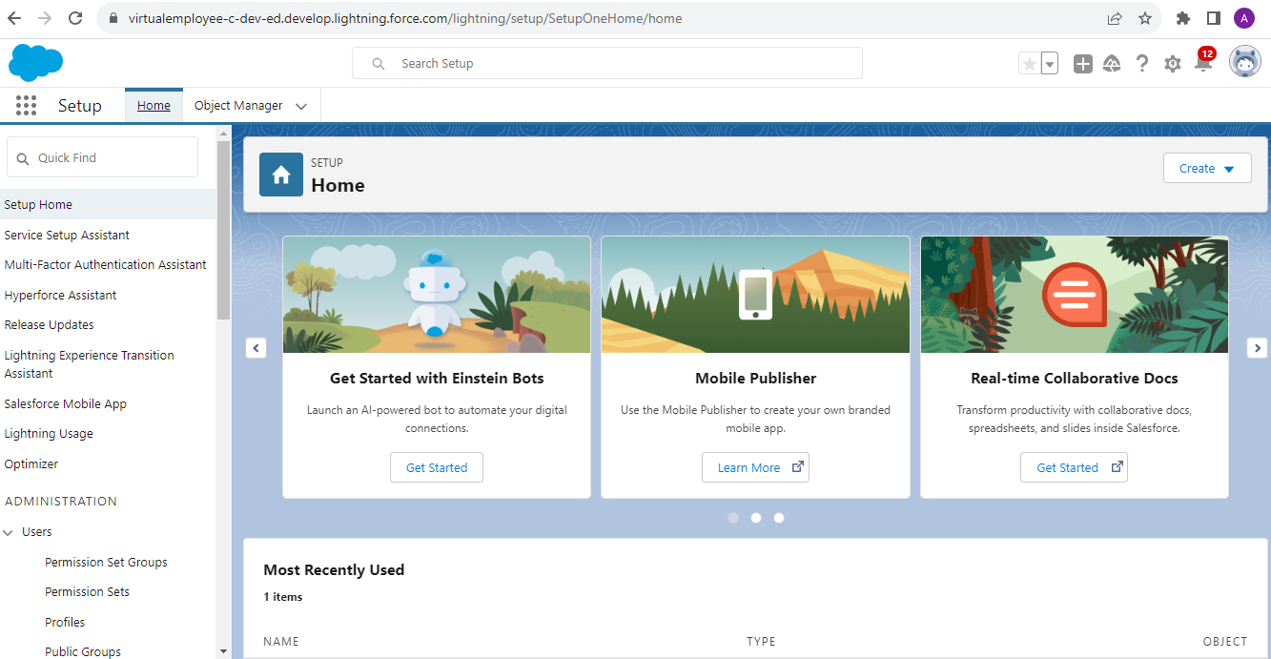

Required Object: -

Standard Objects: Account, Contact, Opportunity.

Custom objects: Vehicle, Driver, Traveler.

Object Created: -

1 Vehicle Object

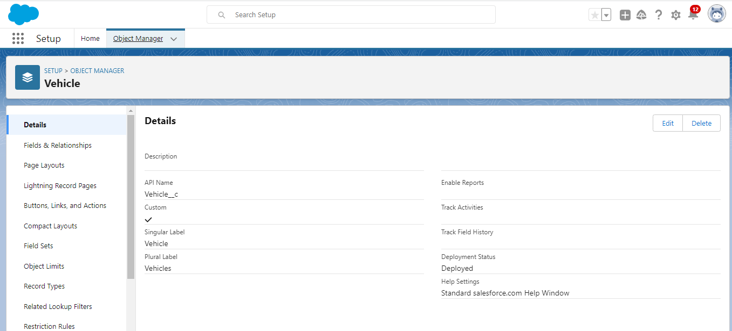

2. Traveller Object

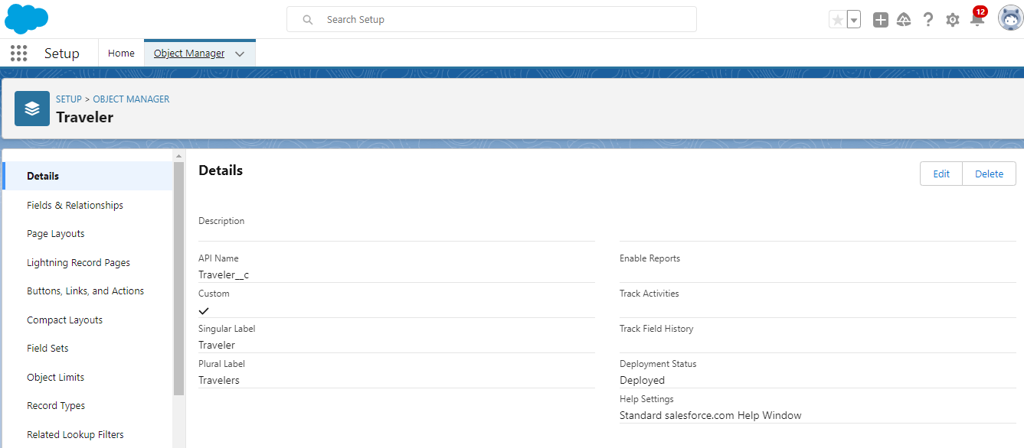

3. Driver Object

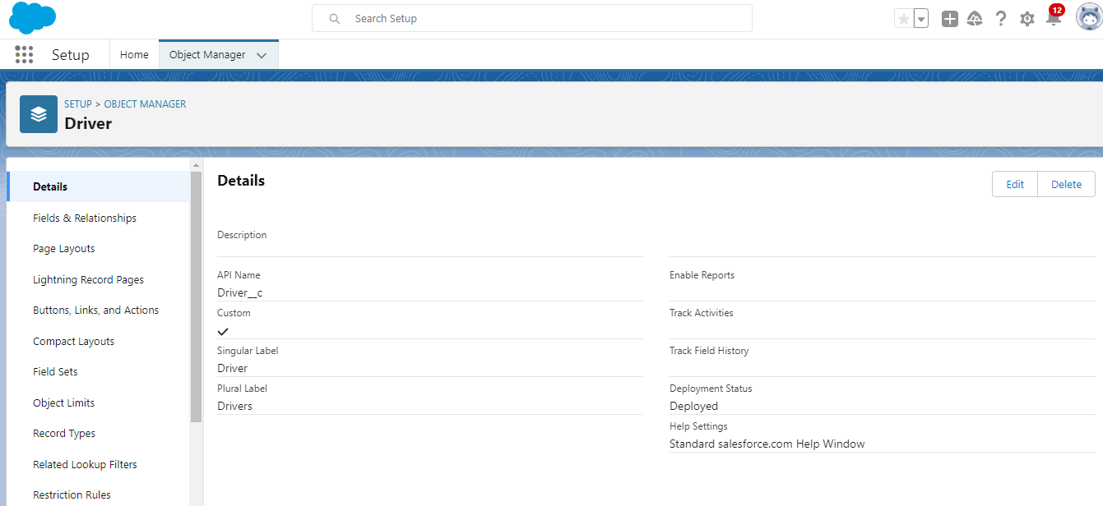

Fields Created in Vehicle Object

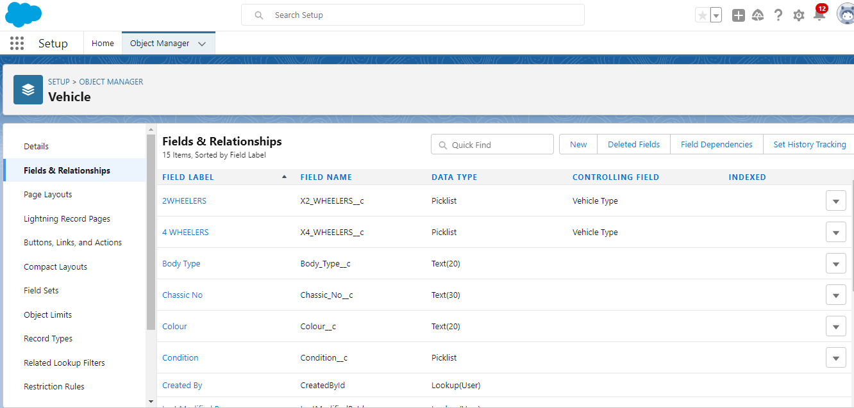

Field Dependency Created as per requirement in-vehicle object.

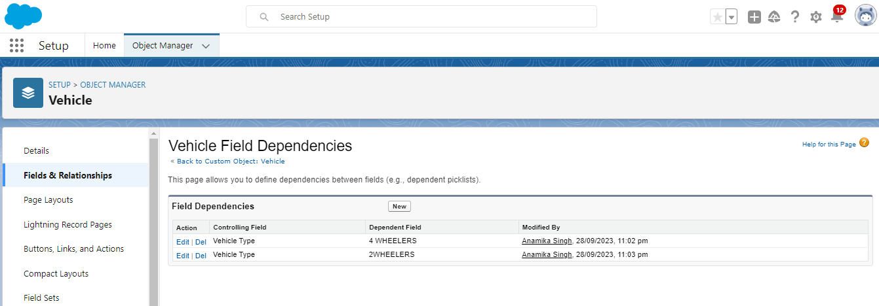

Fields Created in Driver Object

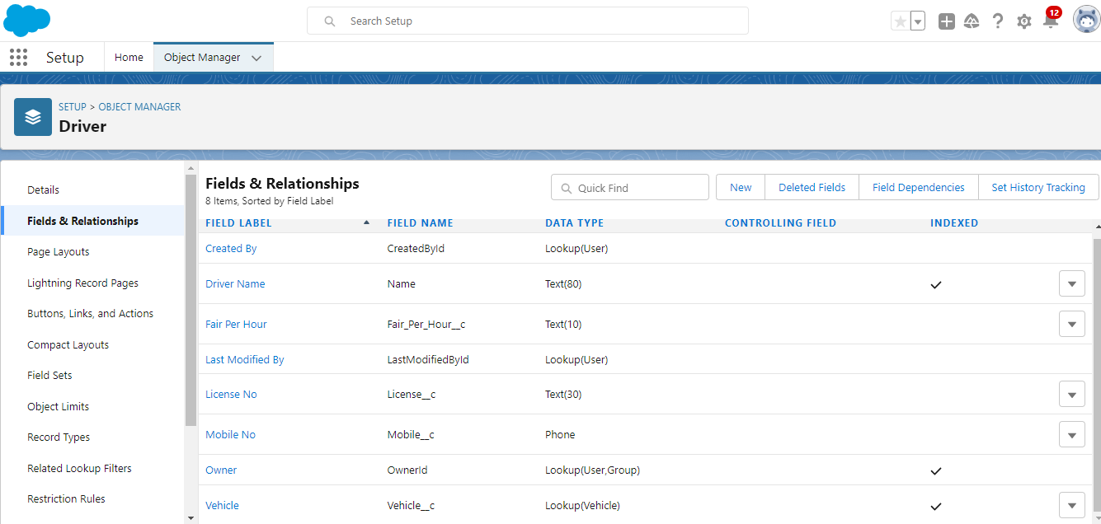

Fields Created in Traveler Object

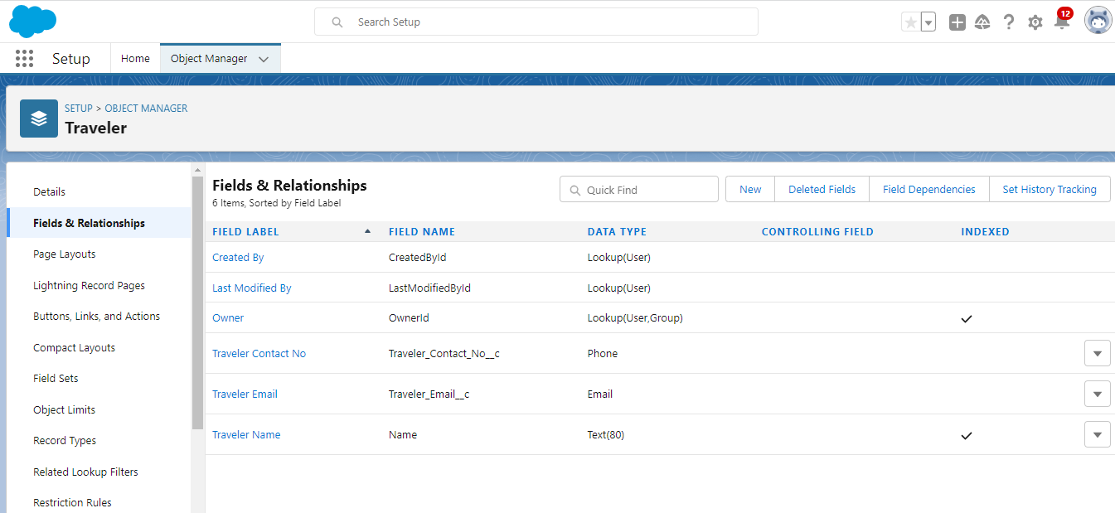

Fields Created in Opportunity Object

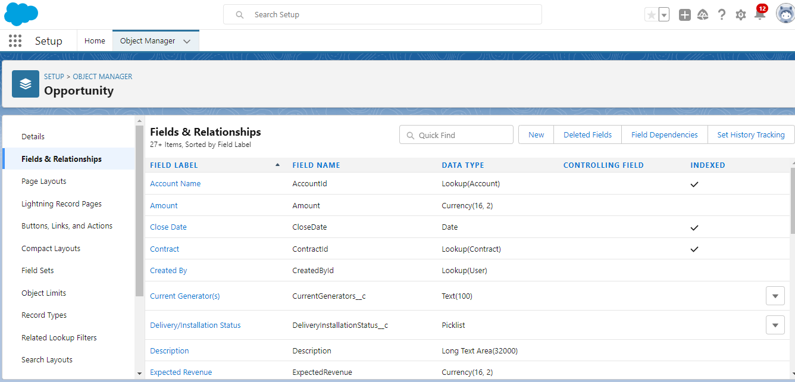

Organised Opportunity Page Layout

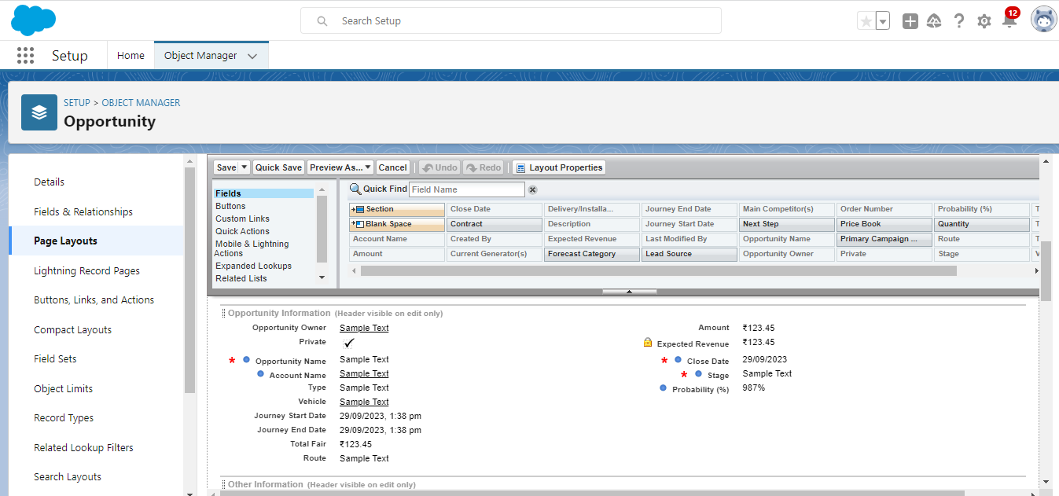

Created Lightning App which name – Vehicle Management

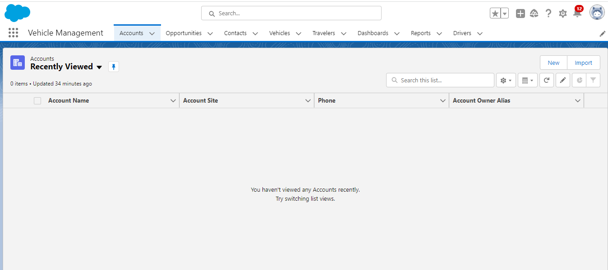

New Profile Created with Name – Vehicle Manager

Create 3 roles as per requirements:

1. Vehicle Manager which reports to CEO
2. Operator1 & Operator 2 which reports to Vehicle Manger

Create New User which name is John teddy, Email – [singhanamika830@gmail.com](mailto:singhanamika830@gmail.com), Username - [johnteddy@vehiclemanagement.com](mailto:johnteddy@vehiclemanagement.com), license – salesforce, role & and profile – vehicle manager

Created other two user as per requirement.

1. Name - Operator1, profile – Operator, Role – Operator1

1. Name – Operator2, Profile – Operator, Role – Operator2

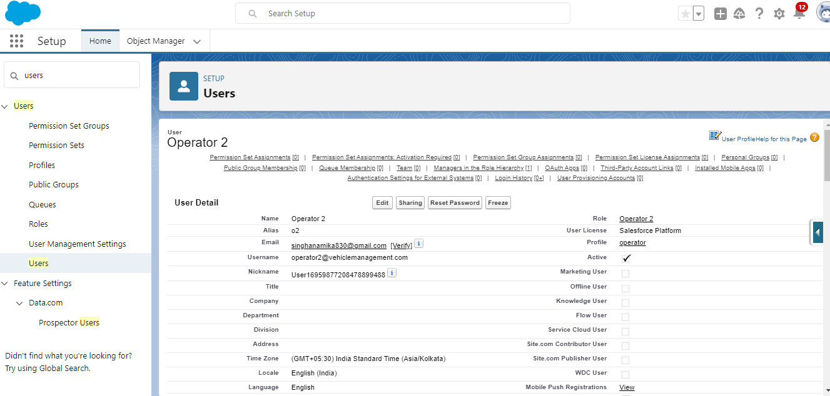

Create Vehicle Record –

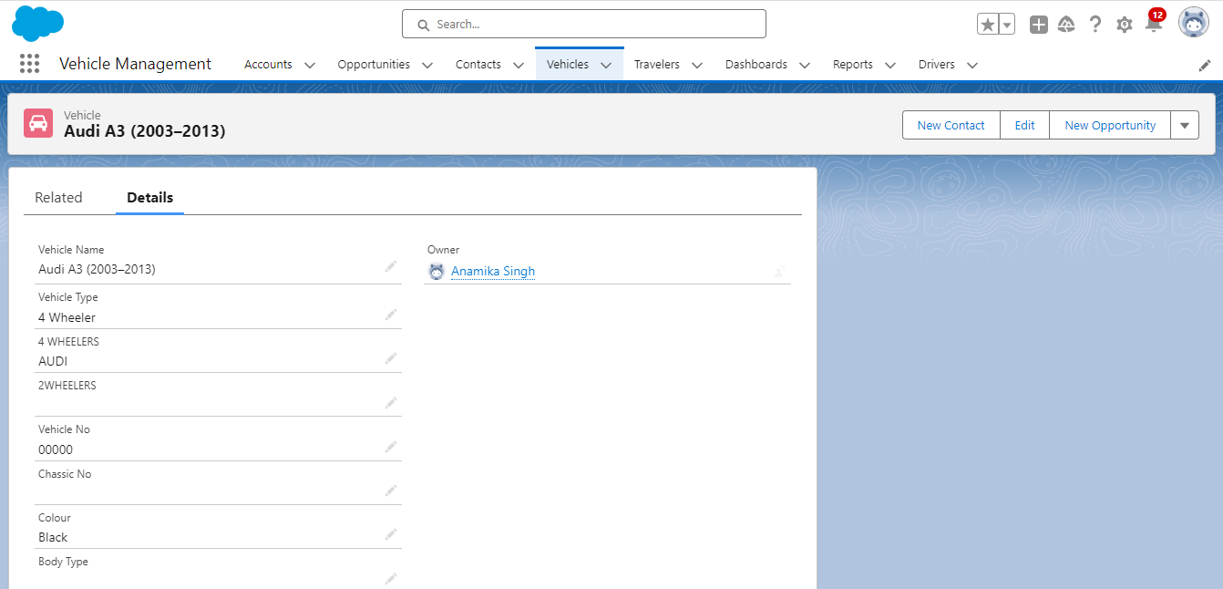

As Per Requirement record need to be delete – done.

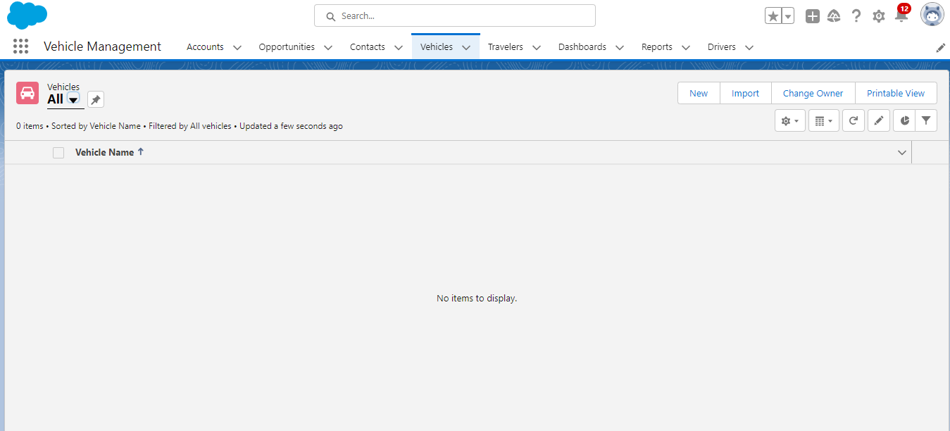

Create Records in Traveler object.

Create Report – Report type is Traveler with opportunity Adding Column Traveler name, Opportunity Name, Account Name, Amount. Group one column and save it with Name of Opportunity Details.

Create Dashboard with Name Opportunity Details, add component selecting report Opportunity details choose graphical representation in vertical form and save this. Here is the output –

